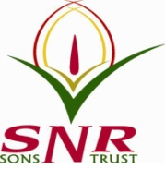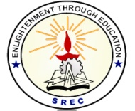**SRI RAMAKRISHNA ENGINEERING COLLEGE**

[Educational Service : SNR Sons Charitable Trust]

[Autonomous Institution, Accredited by NAAC with ‘A’ Grade]

[Approved by AICTE and Permanently Affiliated to Anna University, Chennai]

[ISO 9001:2015 Certified and all eligible programmes Accredited by NBA]

**VATTAMALAIPALAYAM, N.G.G.O. COLONY POST, COIMBATORE – 641 022**

**SREC – IPR CELL**

**Date: 27.06.2021**

**Report on IPR awareness programme for III Year Students:**

An Online IPR awareness programme for III Year Students has been conducted by SREC-IP Cell on 25.06.2021. Mr. P. Ramesh Kannan, M.Sc., M.Phil., L.L.B, Registered Patent Agent at Indian Patent Office, IP Attorney & Partner gave a talk on “Patentability of Projects Amidst the Ever-Expanding Innovations”. 91 students were attended the online webinar and got benefitted.

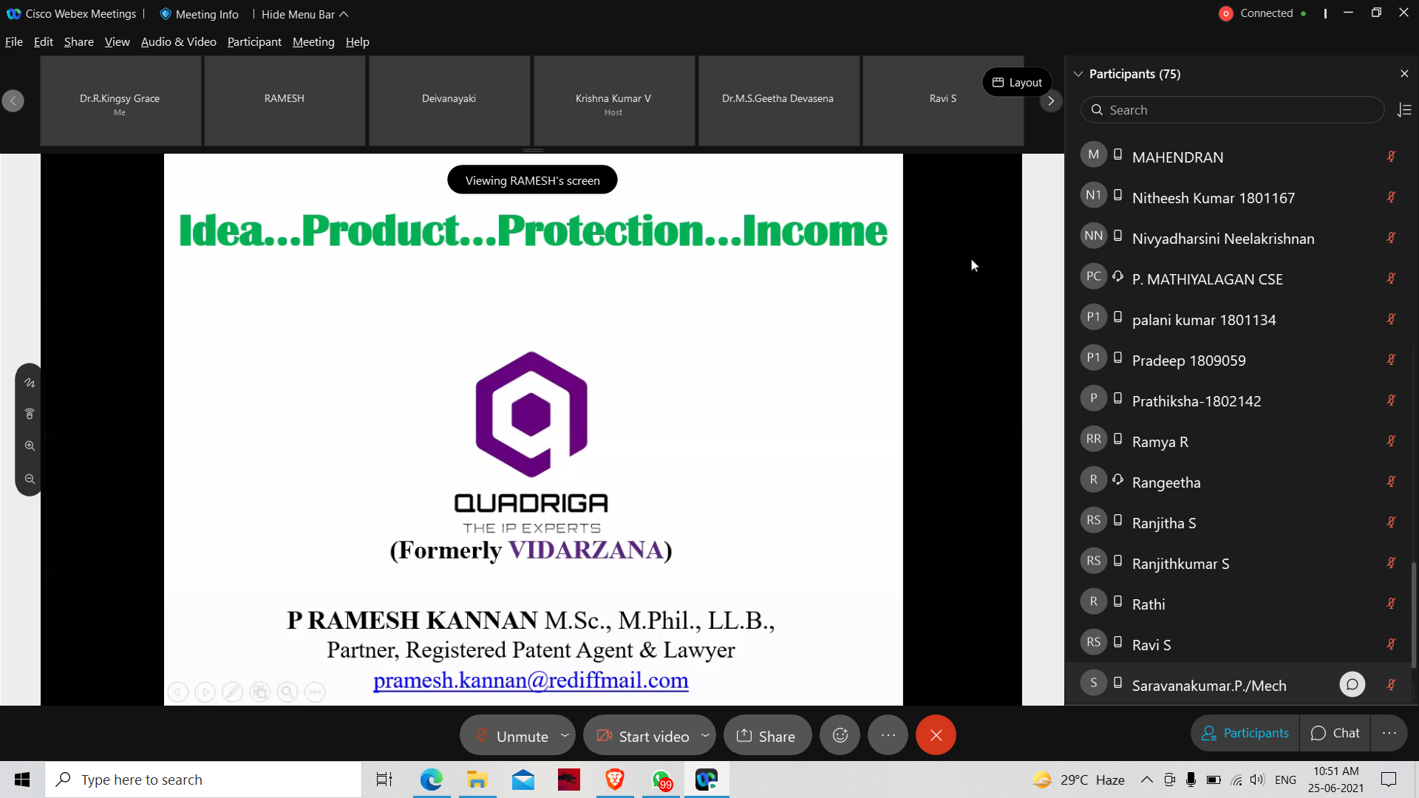

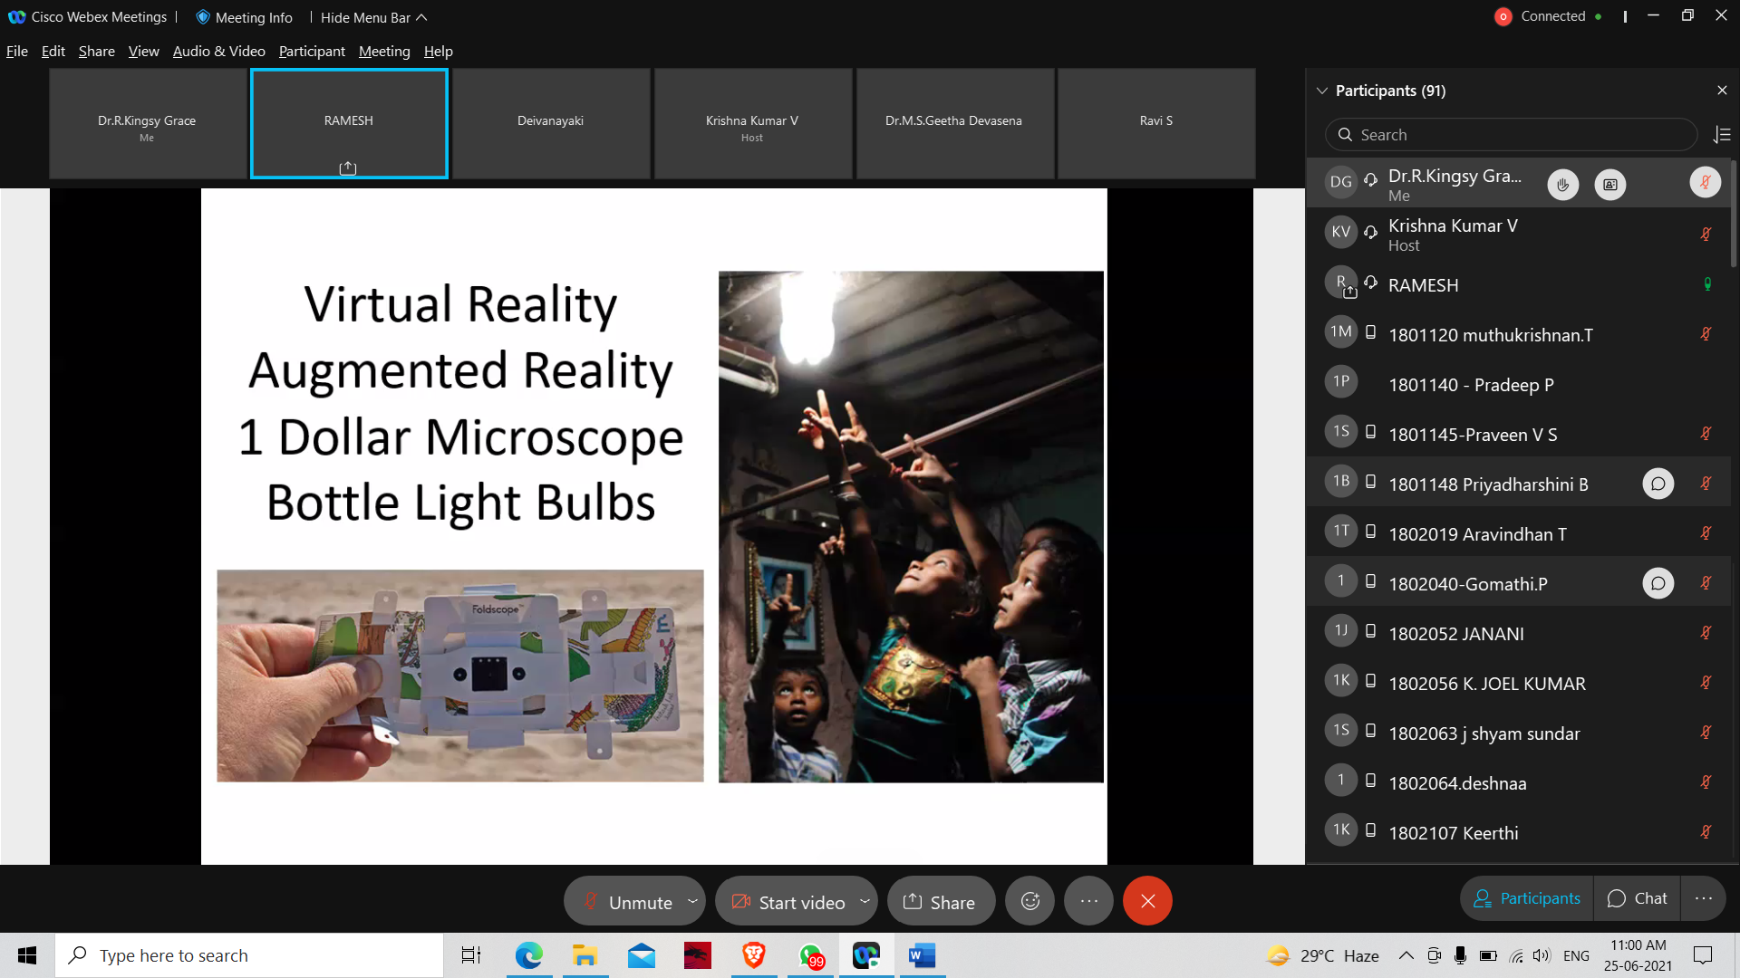

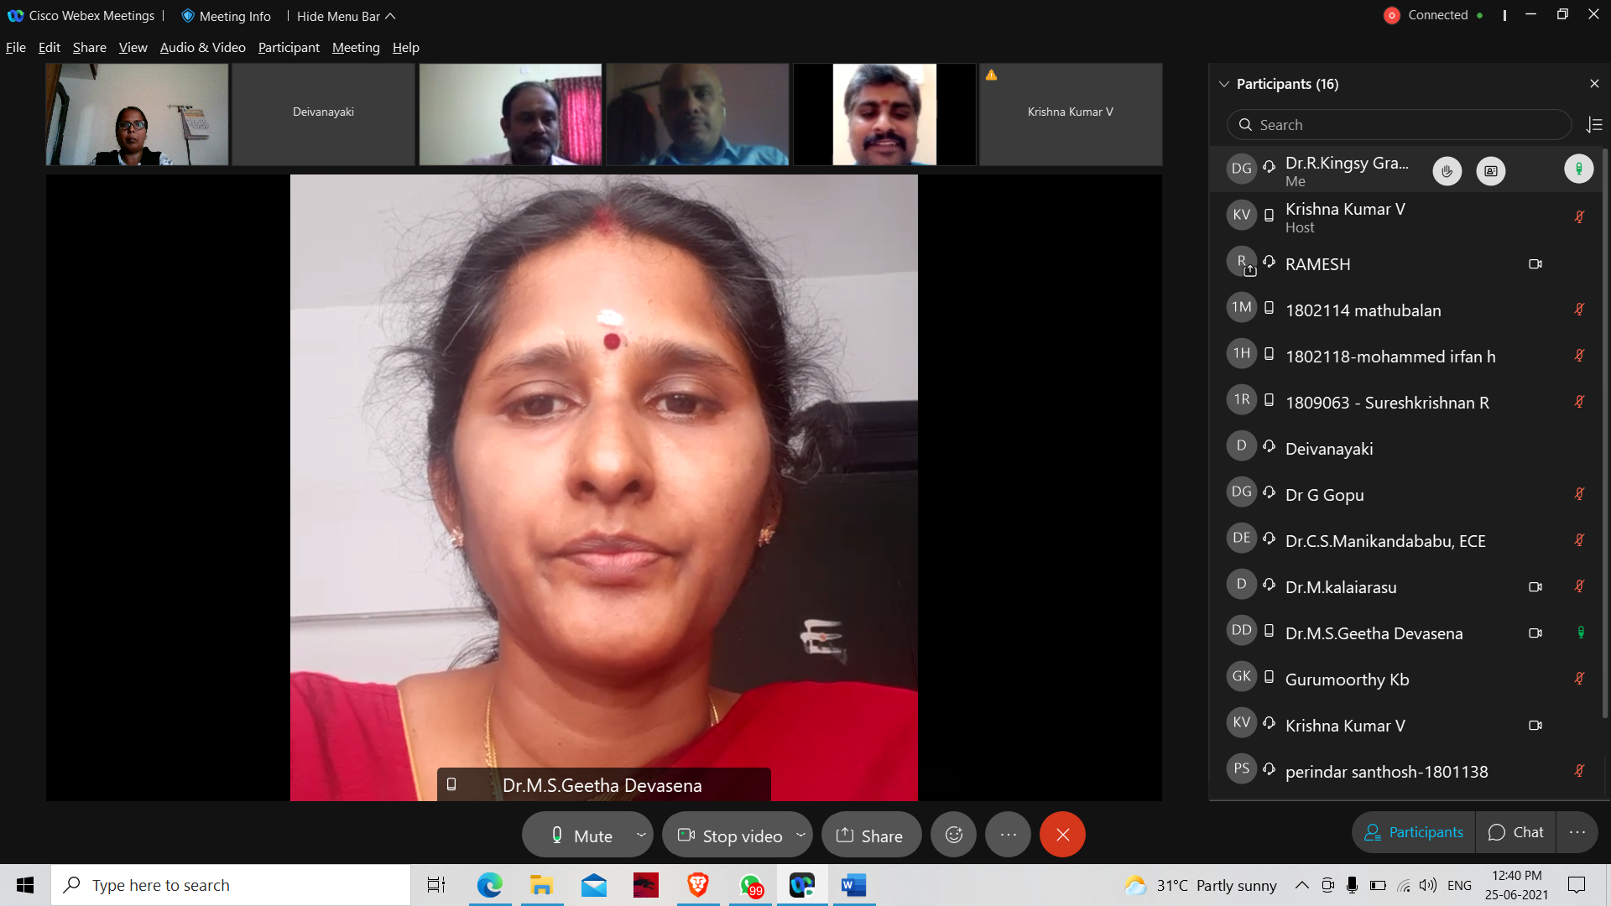

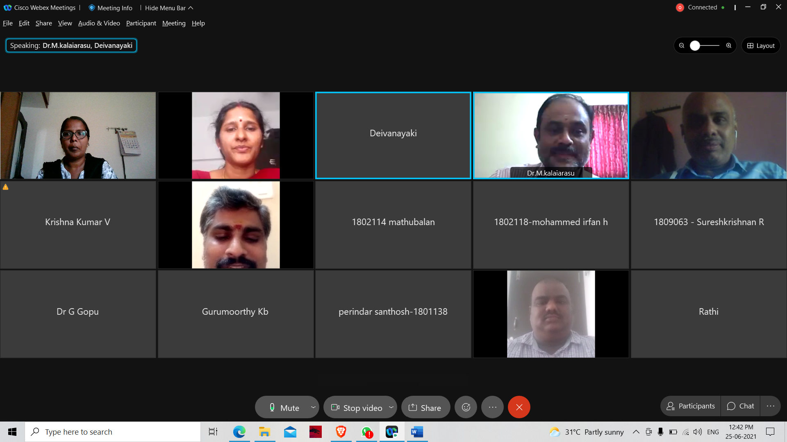

**HEAD – IPR CELL**

**Dr. M. S. Geetha Devasena, P/CSE**